SIMATS ENGINEERING
ASSESSMENT TOOL 2

COURSE NAME: Database Management Systems
COURSE CODE: CSA0508

COURSE OUTCOME COVERED

CO1: Analyze DBMS architecture, different data models, schema types, and design ER/EER diagrams, relational schemas for case-based scenarios by identifying entities and relationships. (BL1, BL2)

Activity Tool : Concept Mapping (Medium)
Assessment Tool Weightage: 35%

Dr

QUESTIONS Total Marks: 50
Q.No | Question | Bloom's Level | Marks
1 | Construct a concept map linking the following terms: DBMS, Schema, Instance, Data Model, ER Diagram, Entity, Attribute, Relationship. | BL2 – Understand | 5
2 | Create a concept map for the three-level ANSI/SPARC architecture showing data independence at each level. | BL2 – Understand | 5
3 | Map the relationship between file-based systems and database systems, highlighting the problems solved by DBMS. | BL2 – Understand | 5
4 | Design a concept map for ER diagram components: entity, weak entity, attribute types, relationship types, and participation constraints. | BL2 – Understand | 5
5 | Construct a concept map comparing Hierarchical, Network, and Relational data models with their key properties. | BL2 – Understand | 5
6 | Develop a concept map for the EER model showing how it extends the basic ER model with generalization, specialization, and aggregation. | BL2 – Understand | 5
7 | Create a visual concept map for the DBMS software architecture, illustrating the flow from user request to data retrieval. | BL2 – Understand | 5
8 | Map the data models discussed in CO1 to real-world applications and explain the suitability of each model. | BL2 – Understand | 5
9 | Construct a concept map for schemas and instances, showing how they relate to physical and logical data independence. | BL2 – Understand | 5
10 | Design a concept map for the roles and responsibilities in a DBMS environment: DBA, End User, Application Developer. | BL1 – Remember | 5

Code of Conduct:

I ALAN PHILIP (192511484) (Name / Reg No) certify that this submission is my original work and that I have adhered to the guidelines specified for this assessment.
I understand that any violation of academic integrity rules will result in disciplinary action.

Signature of the student: 

RUBRICS FOR CALCULATION:

Criteria | Weightage | Level 4 (Exemplary) | Level 3 (Proficient) | Level 2 (Developing) | Level 1 (Beginning)
Concept Identification | 25% | Identifies all key concepts from literature accurately and comprehensively | Identifies most key concepts with minor omissions | Identifies limited concepts; some are irrelevant or missing | Fails to identify essential concepts
Linkages | 25% | Establishes clear, meaningful, and accurate relationships between concepts | Shows correct relationships with minor gaps | Relationships are weak, unclear, or partially incorrect | No meaningful relationships established
Organization | 20% | Concepts are well-structured hierarchically with logical flow and grouping | Mostly organized with minor structural issues | Some organization but lacks clear hierarchy | No logical organization or structure
Integration of Literature | 20% | Integrates multiple studies effectively to show connections and comparisons | Shows some integration of literature | Limited integration; mostly isolated concepts | No integration of literature evidence
Clarity | 10% | Concept map is clear, neat, visually structured, and easy to interpret | Generally clear with minor readability issues | Clarity is reduced; difficult to interpret in parts | Poorly presented and hard to understand

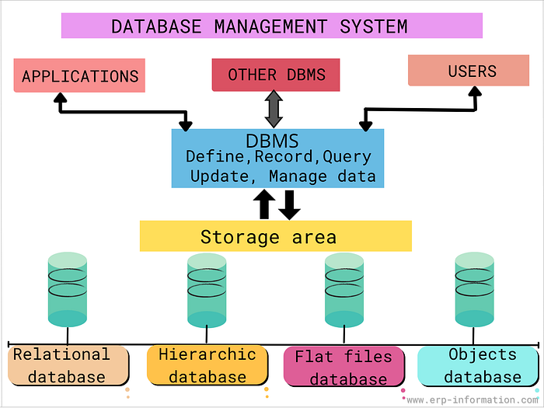

Q1. Concept Map: DBMS, Schema, Instance, Data Model, ER Diagram, Entity, Attribute, Relationship.

DBMS
|
------------------------------------------------
| |
uses a Data Model stores and manages
| |
| |
represented by Database
| |
ER Diagram |
---------------------------- |
| | | |
Entity Attribute Relationship |
| | | |
| | | |
describes describes connects |
\ | / |
\ | / |
------------ Database Structure --------------------------
|
Schema
|
defines the structure of the database
|
|
Instance
(actual data stored at a given time)

- DBMS uses a Data Model to organize data.
- A Data Model is represented using an ER Diagram.
- An ER Diagram consists of Entities, Attributes, and Relationships.
- The Schema defines the structure of the database.
- The Instance represents the actual data stored according to the schema.

Q2. Concept Map: Three-level ANSI/SPARC architecture

ANSI/SPARC Architecture
|
-------------------------------------------------
| | |
External Level Conceptual Level Internal Level
(View Level) (Logical Level) (Physical Level)
| | |
User-specific views Overall database Physical storage
of the database structure of the database
| | |
-----------------------|------------------------
|
Data Independence
|
-----------------------------------
| |
Logical Data Independence Physical Data Independence
| |
Changes in the Conceptual Changes in the Internal
Schema do not affect Schema do not affect the
External Views Conceptual Schema

- External Level: Different users see only the data they need.
- Conceptual Level: Describes the complete logical structure of the database.
- Internal Level: Describes how data is physically stored in memory.
- Logical Data Independence: Changes to the conceptual schema do not affect user views.
- Physical Data Independence: Changes to the internal schema do not affect the conceptual schema.

Q3. Map: File-based System v/s DBMS

File-Based System
|
---------------------------------------
| | | | |
Data Redundancy Data Data Poor Security
Inconsistency Isolation Sharing Problems
| | | | |
---------------------------------------
|
Problems
|
v
DBMS
|
------------------------------------------------
| | | | |
Reduces Data Maintains Integrates Provides Ensures
Redundancy Consistency Data Security Backup &
Sharing Recovery
| | | | |
------------------------------------------------
|
Efficient Database
Management
- File-based systems store data in separate files, which often leads to redundancy, inconsistency, data isolation, poor sharing, and security issues.
- A DBMS solves these problems by reducing redundancy, maintaining data consistency, enabling data sharing, providing security, and supporting backup and recovery.
- As a result, data becomes easier to manage, access, and maintain.

Q4. Concept Map: ER diagram components: entity, weak entity, attribute types, relationship types, and participation constraints.

ER Diagram
|
----------------------------------------------------------------
| | | |
Entity Weak Entity Attribute Relationship
| | | |
| | | |
Strong entity Depends on a ----------------- Connects
(Independent) strong entity | | | | | two or more
| Has partial key | | | | | entities
| Key Simple Composite
| | | |
| Multi- Derived
| valued
|
----------------------------------------------------------------
|
Participation Constraints
|
--------------------------------
| |
Total Participation Partial Participation
(Every entity must (Participation is
participate) optional)

Q5. Concept Map: Hierarchical, Network, and Relational data models

Data Models
|
-------------------------------------------------
| | |
Hierarchical Network Relational
| | |
Tree Structure Graph Structure Table Structure
| | |
Parent → Child Many-to-Many Links Rows and Columns
| | |
One-to-Many Many-to-Many Uses Relations
| | |
Fast Access Flexible Easy to Query
| | |
Rigid Structure Complex Structure Uses SQL
| | |
Difficult to Modify Pointer-Based Links Data Independence

Q6. Concept Map: EER and ER model

EER Model
(Extended Entity Relationship Model)
|
extends the Basic ER Model
|
----------------------------------------------------------------
| | | |
Entity Attribute Relationship Additional Features
| | | |
| | | |
-------------------------------------------------|-------------
|
---------------------------------------
| | |
Generalization Specialization Aggregation
| | |
Combines similar Divides a super Treats a relationship
lower-level entities entity into as a higher-level
into one super entity sub-entities entity
| | |
Common attributes Unique attributes Relationship
are shared are inherited participates in
another relationship
| | |
Example: Example: Example:
Savings & Current Employee → Employee works on
Account → Account Manager, Clerk Project supervised
by Manager

Q7. Concept Map: DBMS Architecture

User
|
| Sends Query / Request
v
+--------------------+
| Application / |
| Interface |
+--------------------+
|
v
+--------------------+
| DBMS |
+--------------------+
|
-----------------------------------------------------------------
| | | |
| | | |
v v v v
+-------------+ +---------------+ +---------------+ +----------------+
| Query | | Transaction | | Authorization | | Storage |
| Processor | | Manager | | & Integrity | | Manager |
+-------------+ +---------------+ +---------------+ +----------------+
| |
| |
---------------------------------------------------------
|
v
+--------------------+
| Database Files |
| (Tables, Indexes) |
+--------------------+
|
| Retrieves Data
v
+--------------------+
| DBMS |
+--------------------+
|
v
+--------------------+
| Query Result / |
| Retrieved Data |
+--------------------+
|
v
User

Q9. Concept Map: Schema and Instances

Database
|
----------------------------
| |
Schema Instance
(Database Structure) (Actual Data)
| |
Changes Rarely Changes Frequently
|
---------------------------------------
| | |
External Schema Conceptual Schema Internal Schema
(View Level) (Logical Level) (Physical Level)
| | |
User Views Overall Structure Physical Storage
| | |
-------------------|------------------
|
Data Independence
|
----------------------------------
| |
Logical Data Independence Physical Data Independence
| |
Changes to the Conceptual Changes to the Internal
Schema do not affect Schema do not affect
External Schemas the Conceptual Schema

Q10. Concept Map: DBMS Environment (DBA, End User, Application Developer)

DBMS Environment
|
------------------------------------------------
| | |
DBA End User Application Developer
| | |
---------------- ---------------- ----------------------
| | | | | | | | | |
Design Security Backup Access Insert Update Design Develop Test
Database Manage Recovery Data Delete Data Apps Queries Maintain
| | | | | |
Performance User Data Generate Forms Reports
Tuning Accounts Integrity Reports Interfaces
|
Database
Maintenance

- DBA (Database Administrator): Designs the database, manages security, performs backup and recovery, maintains data integrity, creates user accounts, and improves performance.
- End User: Accesses the database to insert, update, delete, and retrieve data according to their needs.
- Application Developer: Develops database applications, writes SQL queries, designs forms and reports, tests, and maintains the application.

